Implement services for managing Country

1.application.properties
spring.datasource.url=jdbc:mysql://localhost:3306/your_database_name
spring.datasource.username=your_username
spring.datasource.password=your_password
spring.jpa.hibernate.ddl-auto=validate
spring.jpa.show-sql=true
spring.jpa.properties.hibernate.dialect=org.hibernate.dialect.MySQL8Dialect

2. Create Entity:
import jakarta.persistence.Entity;
import jakarta.persistence.Id;
import jakarta.persistence.Table;

@Entity
@Table(name = "country")
public class Country {

@Id
private String coCode;

private String coName;

// Getters and setters
public String getCoCode() {
return coCode;
}

public void setCoCode(String coCode) {
this.coCode = coCode;
}

public String getCoName() {
return coName;
}

public void setCoName(String coName) {
this.coName = coName;
}
}

3. Repository:
import org.springframework.data.jpa.repository.JpaRepository;
import java.util.List;

public interface CountryRepository extends JpaRepository<Country, String> {
List<Country> findByCoNameContainingIgnoreCase(String partialName);
}

4. Service:
import org.springframework.beans.factory.annotation.Autowired;
import org.springframework.stereotype.Service;
import org.springframework.transaction.annotation.Transactional;
import java.util.List;
import java.util.Optional;

@Service
public class CountryService {

@Autowired
private CountryRepository countryRepository;

public Optional<Country> findByCode(String code) {
return countryRepository.findById(code);
}

@Transactional
public Country addCountry(Country country) {
return countryRepository.save(country);
}

@Transactional
public Country updateCountry(Country country) {
return countryRepository.save(country);
}

@Transactional
public void deleteCountry(String code) {
countryRepository.deleteById(code);
}

public List<Country> findByPartialName(String name) {
return countryRepository.findByCoNameContainingIgnoreCase(name);
}
}

5. Controller
import org.springframework.beans.factory.annotation.Autowired;
import org.springframework.web.bind.annotation.*;

import java.util.List;
import java.util.Optional;

@RestController
@RequestMapping("/countries")
public class CountryController {

@Autowired
private CountryService countryService;

@GetMapping("/{code}")
public Optional<Country> getCountry(@PathVariable String code) {
return countryService.findByCode(code);
}

@PostMapping
public Country addCountry(@RequestBody Country country) {
return countryService.addCountry(country);
}

@PutMapping
public Country updateCountry(@RequestBody Country country) {
return countryService.updateCountry(country);
}

@DeleteMapping("/{code}")
public void deleteCountry(@PathVariable String code) {
countryService.deleteCountry(code);
}

@GetMapping("/search")
public List<Country> searchCountries(@RequestParam String name) {
return countryService.findByPartialName(name);
}
}

OUTPUT:

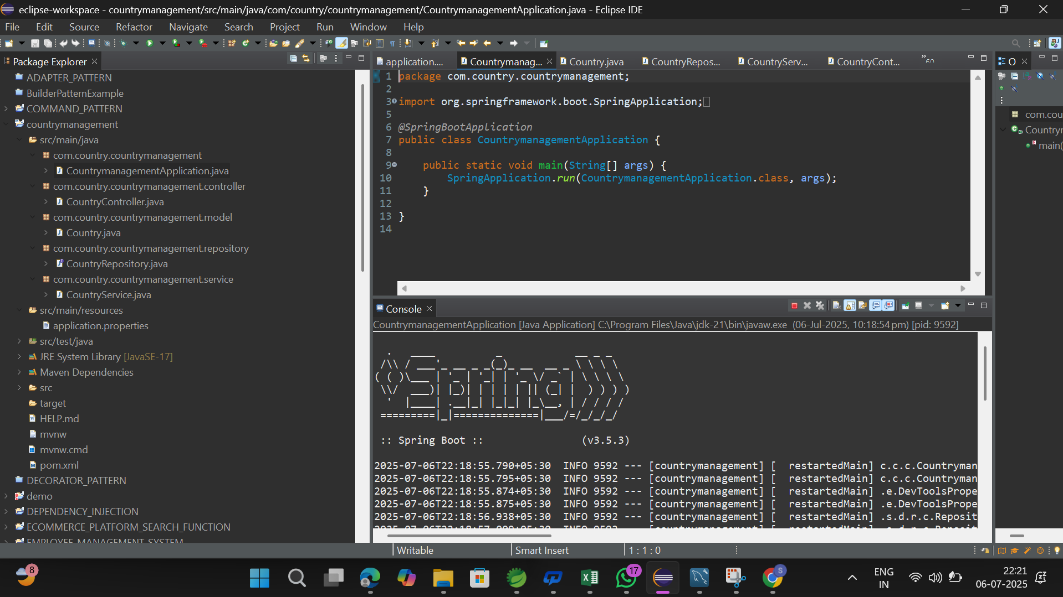

MYSQL:
